1
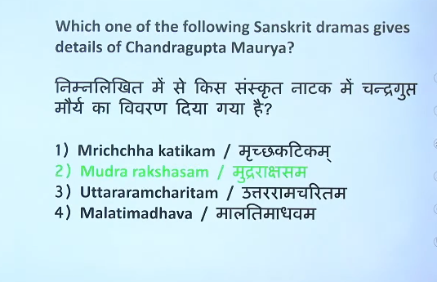

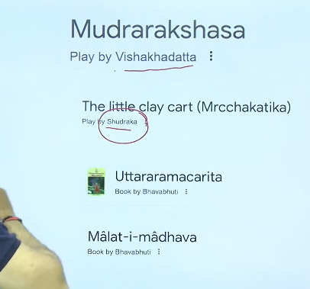

2

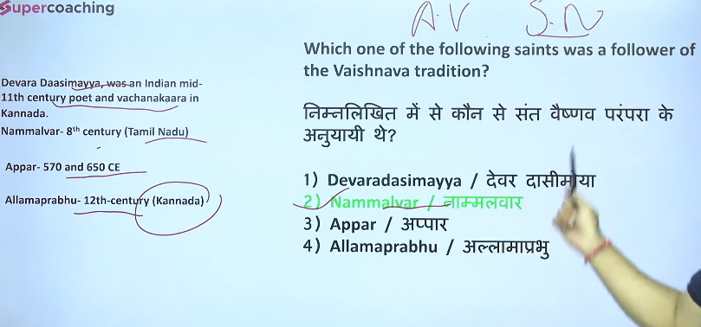

3
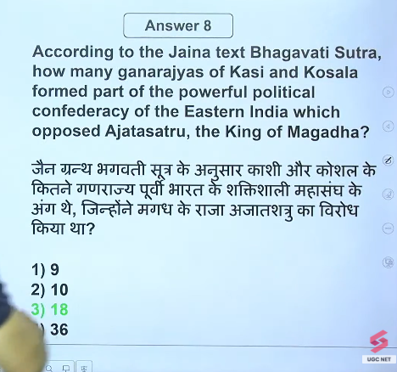
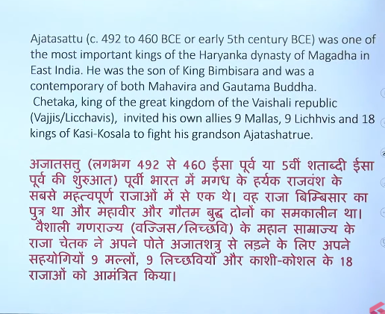
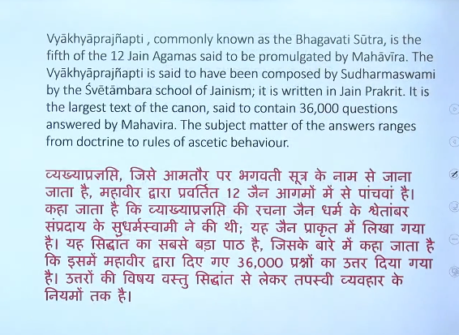

4
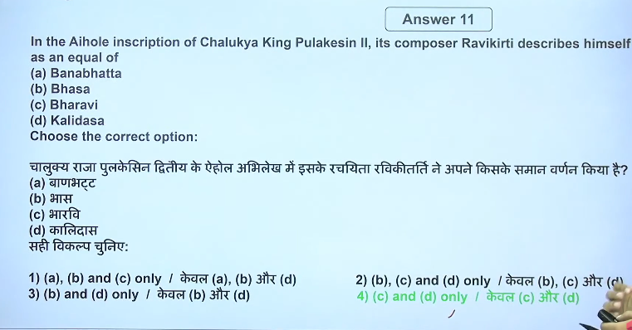
Compare himself from bhash kalidas bhairav basically correct is b, c, d but ugc answer is different

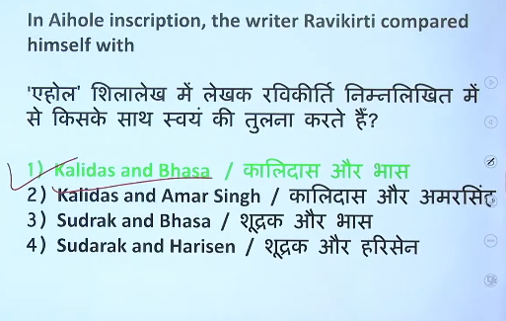

5
प्रारम्भिक मध्यकालीन भारत में क्षेत्रीय राजनीति के विकास के साथ-साथ दरबारी कवियों द्वारा राजाओं की जीवनी की रचना भी की गई।
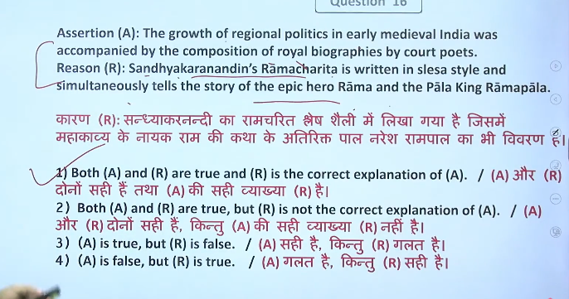

6
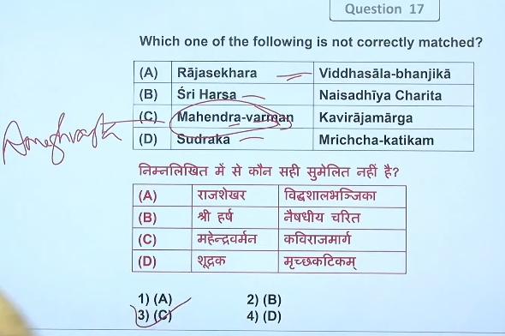
amoghvarsha
Amoghvarsha- mahendravarman

7
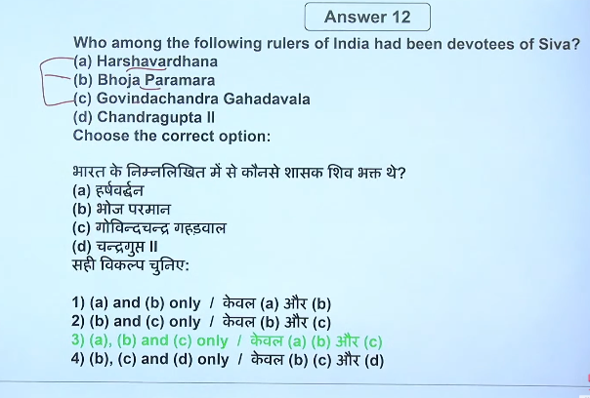
1114 to 1155 CE
1010 CE to 1055 CE
606–647 CE
Harshavardhana (reigned 606–647 CE) was a prominent ruler of the Pushyabhuti dynasty who unified northern India from his capital at Kannauj. His reign marked a "golden age" of cultural growth, literature, and religious tolerance, famously documented by the Chinese pilgrim Xuanzang. Harsha's empire, stretching from Punjab to Bengal, dissolved after his death.

Raja Bhoja of the Paramara dynasty ruled from roughly 1010 CE to 1055 CE. As a renowned 11th-century scholar-king based in Dhara (present-day Dhar, Madhya Pradesh), he was a patron of literature and science, and a warrior who expanded his kingdom despite facing multiple enemies.
- Reign Period: Approximately 1010–1055 CE.
- Dynasty: Paramara dynasty of Malwa.
- Capital: Dhara (Dhar, Madhya Pradesh).
- Legacy: Known as a "scholar-king" and polymath, he wrote numerous works on subjects like engineering, poetry, architecture (e.g., Samarangana Sutradhara), and built the city of Bhojpur.
- Military: His empire stretched from Vidisha in the east to the Sabarmati River in the west, and from Chittor in the north to Konkan in the south.
Note: He is distinct from the 9th-century Gurjara-Pratihara king, Mihira Bhoja.

Govindachandra of the Gahadavala dynasty reigned from approximately 1114 to 1155 CE. As a prominent 12th-century ruler, he solidified Gahadavala power in North India, particularly in modern-day Uttar Pradesh and Bihar, with his capital at Varanasi. He was known for defending the region against Ghaznavid invasions and fostering cultural growth.
Key details of his reign include:
- Accession: He was the son of Madanapala and ascended the throne around 1114 CE.
- Military Success: He maintained a large army, repulsed Muslim attacks from the west, and expanded the kingdom to include the Patna and Munger areas.
- Administration: His reign was marked by stability and the expansion of the kingdom from Kannauj and Varanasi.
- Legacy: He was a patron of both Hindu temples and Buddhist monasteries, with a significant number of his inscriptions found across Uttar Pradesh.
He was succeeded by his son, Vijayachandra.
Chandragupta II (reigned c. 380–415 CE) was a devout follower of Lord Vishnu (Vaishnavism). He often adopted the title Paramabhagavata (supreme devotee of Vishnu) in his inscriptions and coins, and used the Garuda symbol (Vishnu's vehicle) as his imperial emblem.
Chandragupta II, also known as Vikramaditya, reigned over the Gupta Empire from approximately 375/380 CE to 415 CE. His 35–40 year reign marked the pinnacle of the Gupta Empire's power, territorial expansion, and cultural "Golden Age," succeeding his father, Samudragupta, and preceding Kumargupta I.
Key Details of His Reign:
- Reign Duration: ~375–415 CE (some sources narrow this to 380–413/415 CE).
- Dynasty: Gupta Dynasty.
- Title: Commonly referred to as Vikramaditya or Chandragupta Vikramaditya.
- Territorial Expansion: Expanded the empire to its maximum extent, covering North India and defeating the Western Kshatrapas (Shakas).
- Cultural Significance: Famous for patronizing arts and literature; his court is associated with the Navratnas (Nine Gems), including Kalidasa.
- Successor: His son, Kumaragupta I, took the throne in 415

8
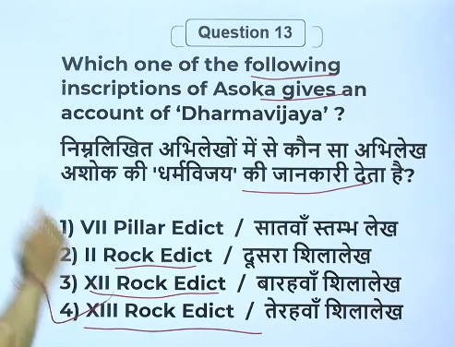
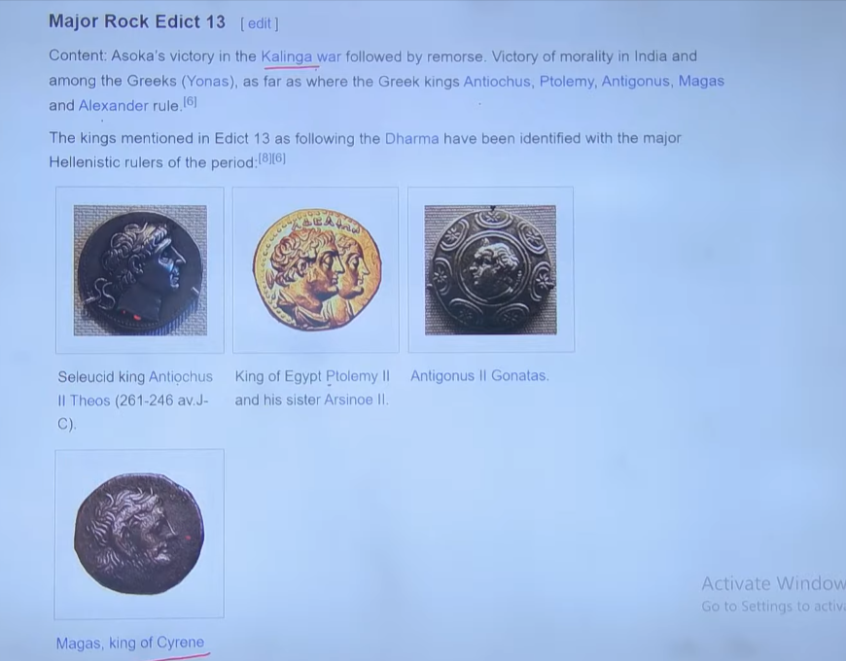

9
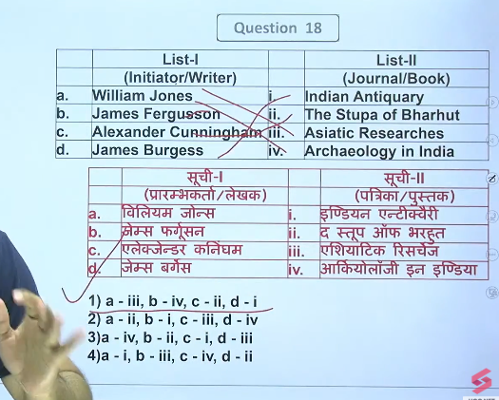

11
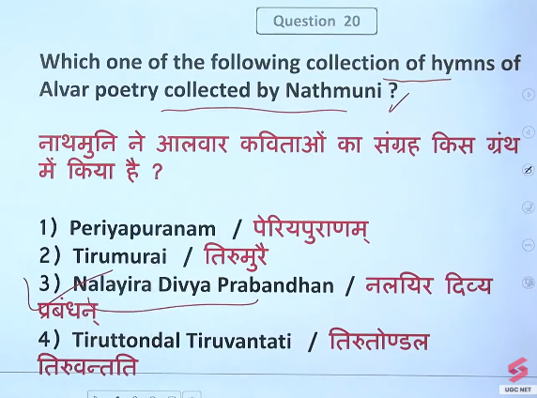

12
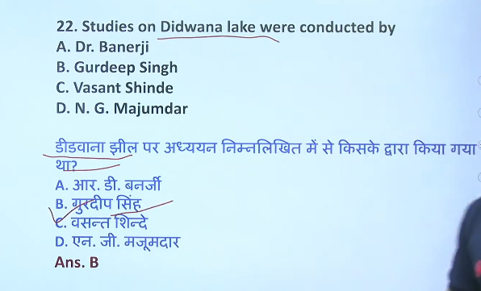

13

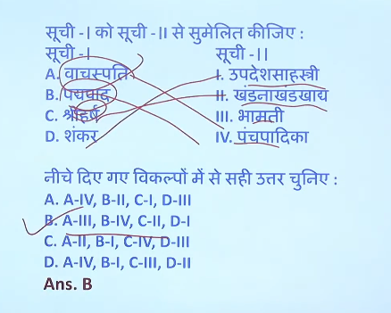
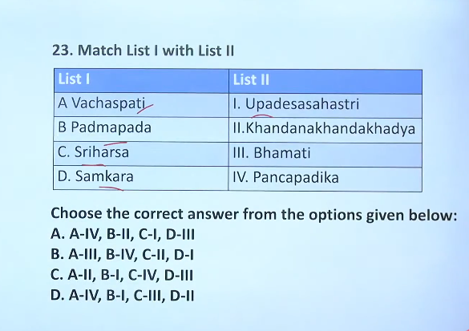

14

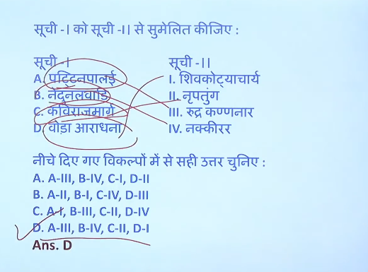
Yes, Pattinappalai is intrinsically related to the poet Kadiyalur Uruthirankannanar.
Kavirajamarga is a landmark 9th-century treatise on Kannada poetics, rhetoric, and grammar, which is intrinsically linked to Amoghavarsha I (reigned 814–878 CE), a renowned Rashtrakuta emperor who held the title Nrupatunga. It is recognized as the oldest available literary work in the Kannada language

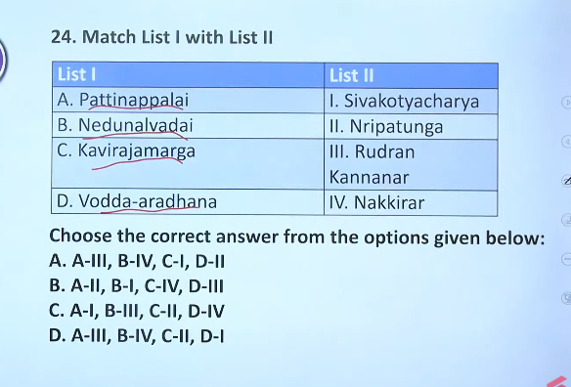

15
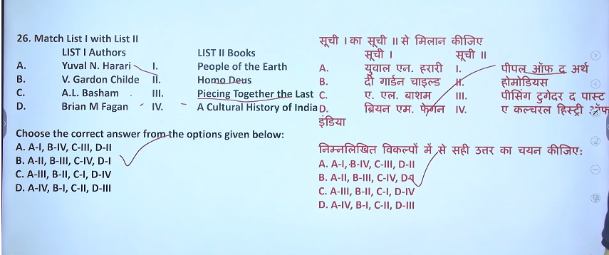
Ans: B

16
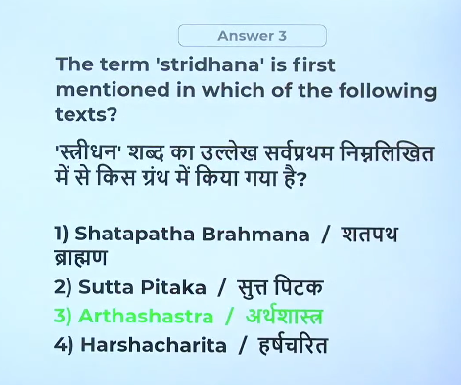
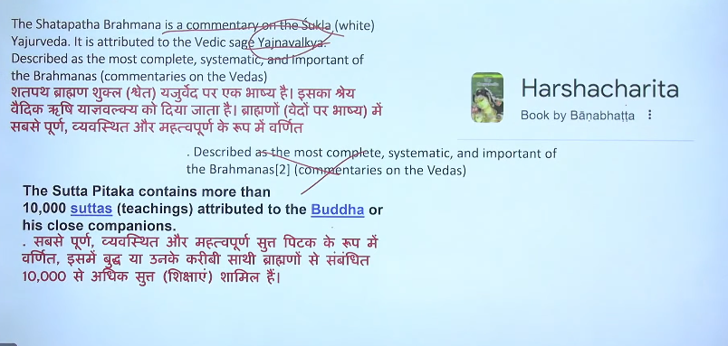

17
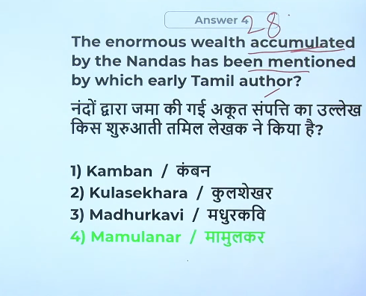
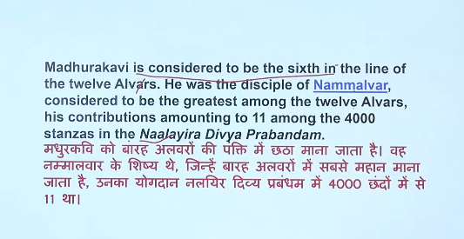
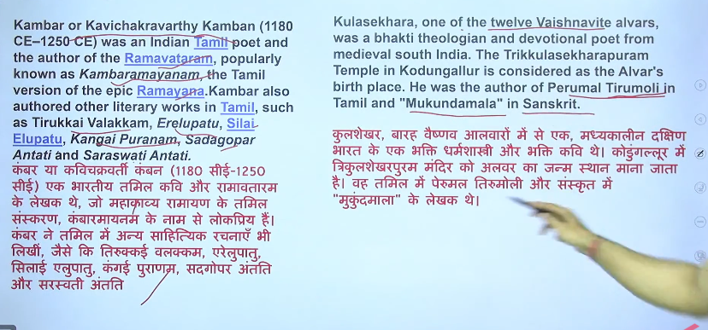

18
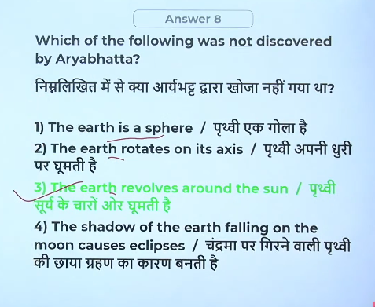
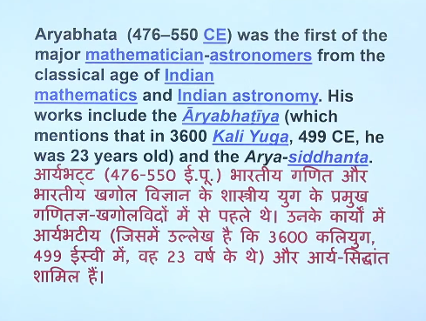

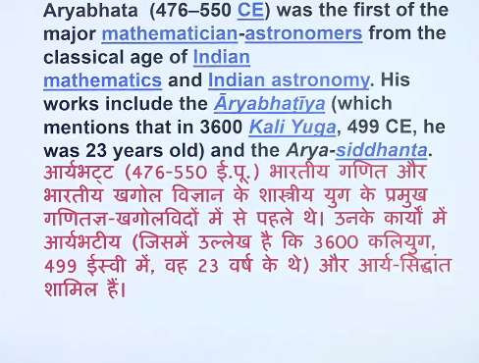

19
